**Cycle-1**

1. Print your name to the screen with every letter being a different heading size

<html

>

<head>

<style>

.a h2{position: absolute;left: 34px;top:-5px;}

.a h3{position: absolute;left: 50px;top:0px;}

.a h4{position: absolute;left: 65px;top: 1px;}

.b h1{position: absolute;left: 99px;top: -14px;}

.b h2{position: absolute;left: 122px;top: -5px;}

</style>

</head>

<body>

<div class="a">

<h1><font color="red">R</font></h1><h2><font color="blue">O</font></h2><h3><font color="yellow">N</font></h3><h4><font color="#ff4ffg">Y</font></h4>

</body>

</html>

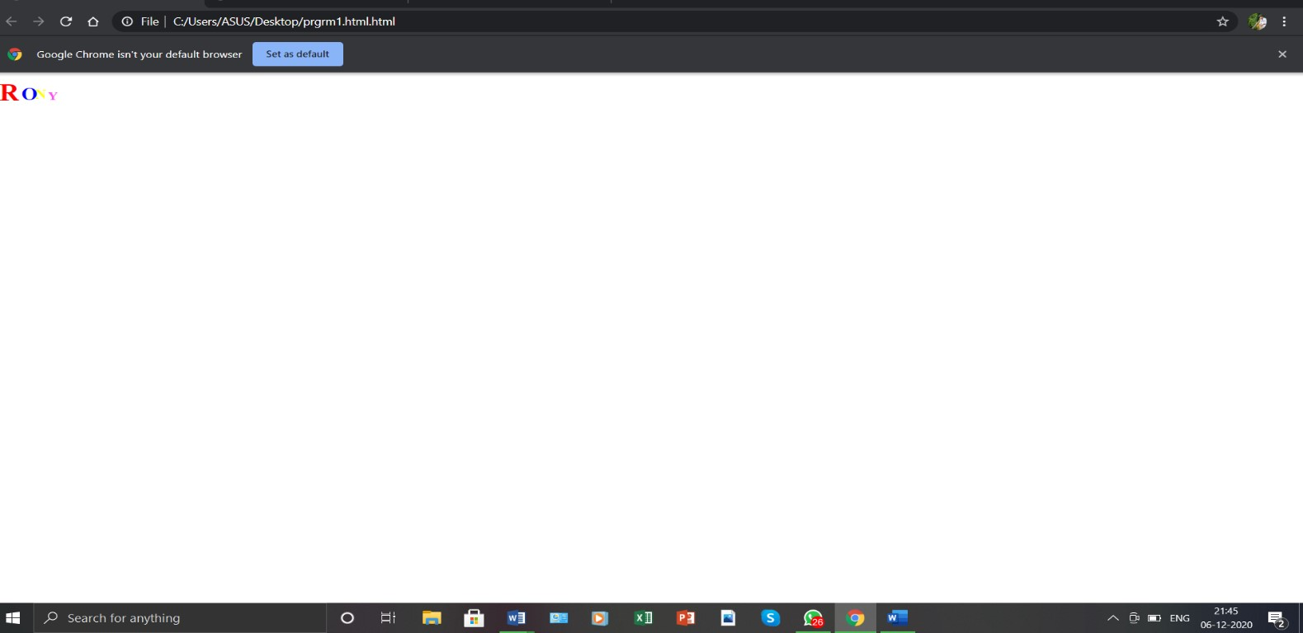

2. Display the following text:

H2O

12th April 2016

HTML stands for ~~High Text Markup Language~~ He said <**I am fine**>

<html

>

<head> <style>

h2{position: absolute;left: 70px;top: 169px;}

</style>

</head>

<body>

<h1>H<sub>2</sub>O</h1>

<h1>12<sup>th</sup>April 2016</h1>

<h1>HTML stands for <s>High Text Markup Language</s></h1>

<h4>He said</h4><h2><b>I am fine</b></h2>

</body>

</html>

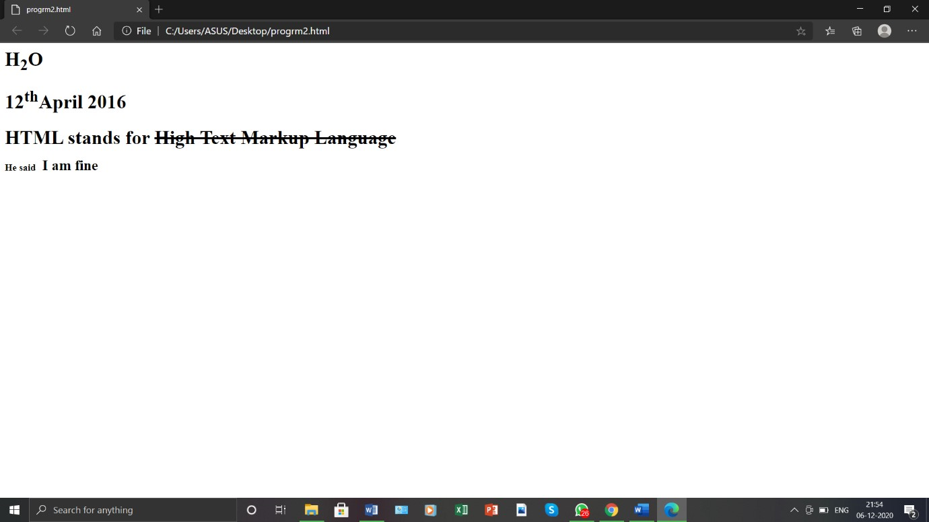

3. Print a paragraph with 4 - 5 sentences. Each sentence should be a different font.

<html

>

<head>

</head>

<body>

<font size="1"><p>Social Media is where we can post, search, talk, and get

associated with others.</font>

<font size="3">Almost every person on the planet utilizes different internet based

life stages.</font>

<font size="5">Social Media is an excellent stage for the promotion of your

business and items.</font>

<font ize="7">Social media can be addictive.</p></font>

</body>

</html>

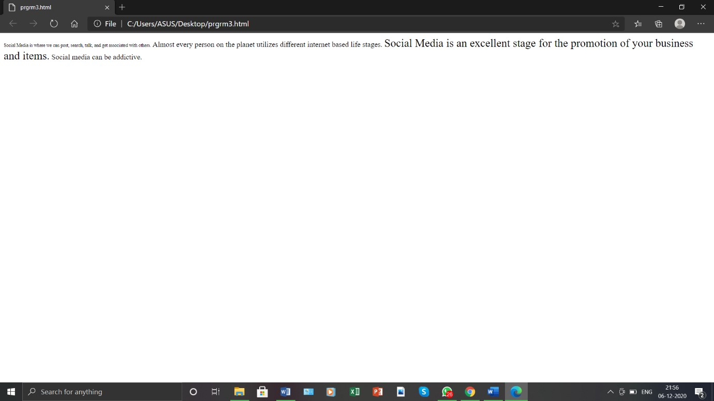

4. Print a paragraph that is a description of a book, include the title of the book as well as its author. Names and titles should be underlined, adjectives should be italicized and bolded

<html>

<head> <style>

h1{position: absolute;left: 450px;} h4{position: absolute;top: 93px; } h3{position: absolute;top: 60px;left: 500px;}

</style>

</head>

<body>

<div class="a">

<h1><u>Apple Cart</u></h1>

<h3>Author:<u>G.B.Shaw</u></h3>

<p><h4>The Apple Cart, which was completed in December 1928, is a wry political satire by George Bernard Shaw. Its plot concerns a monarch who is assaulted by his elected cabinet. They feel that the king is <i>too</i> meddlesome and threaten to resign if he does not sign an ultimatum, which in effect would strip him of his authority and turn him into a powerless figurehead. Either way, the king would be doomed, without a cabinet or without power; his dilemma is the play's catalyst. What follows is political debate, as many sides

and problems are discussed and revealed. Added to the commentary on politics is a brief interlude on marriage and adultery, as well as a scene with an American ambassador mocking full democracy and capitalism. Coupled with Shaw's astute insight and sparkling wit, the play succeeds brilliantly in exposing 'the unreality of both democracy and royalty as our idealists conceive them.' His adept portrayal of Breakages, Limited, offers foresight and perspective into the 'destruction, waste, and disease' brought by <i>private</i> capitalism that are all too topical today.</h4></p>

</div>

</body>

</html>

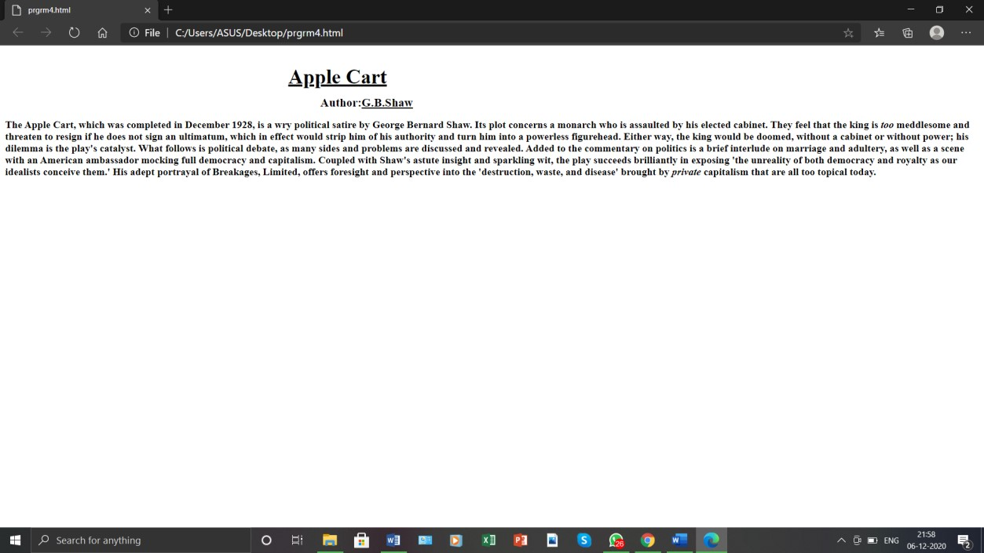

5. Print two lists with any information you want. One list should be an ordered list, the other list should be an unordered list.

<html>

<head>

</head>

<body>

<ul type="square">

<li>laptop</li>

<li>mobile</li>

<li>Radio</li>

</ul>

<ol type="a">

<li>amazon prime</li>

<li>netflix</li>

<li>hotstar</li>

</ol>

</body>

</html>

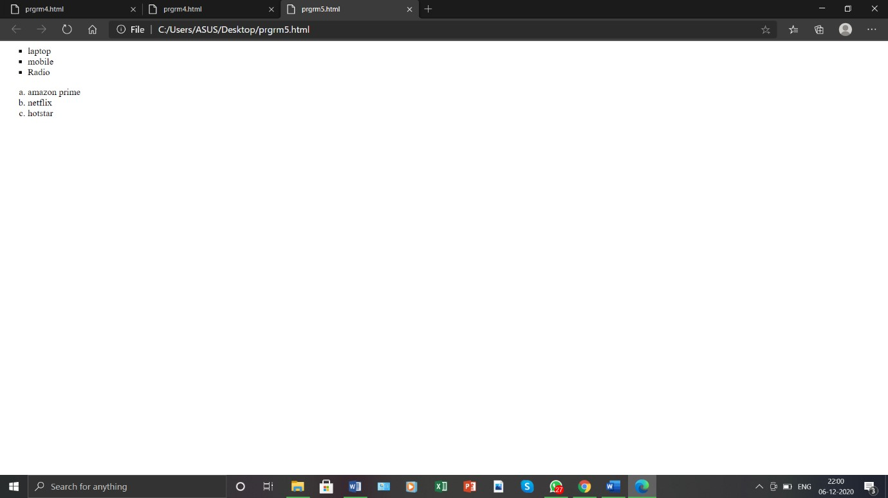

6. Prints 10 names with a line break between each name. The list should be alphabetized, and to do this place a subscripted number next to each name based on where it will go in the alphabetized list. (Example: Alan1). Print first, the unalphabetized list with a subscript number next to each name, then the alphabetized list. Both lists should have an <h1> level heading

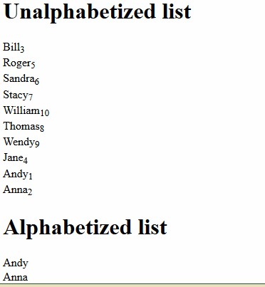

<html> <head>

</head>

<body>

<h1>Unalphabetized list</h1>

<ol type="1">

<li>bill<sub>5</sub></li>

<li>roger<sub>3</sub></li>

<li>sandra<sub>6</sub></li>

<li>stancy<sub>7</sub></li>

<li>william<sub>10</sub></li>

<li>thomas<sub>8</sub></li>

<li>wendy<sub>9</sub></li>

<li>jane<sub>4</sub></li>

<li>andy<sub>1</sub></li> <li>anna<sub>2</sub></li>

</ol>

<h1>Alphabetized</h1>

<ol type="a">

<li>andy</li>

<li>anna</li>

<li>rogar</li>

<li>jane</li>

<li>bill</li>

<li>sandra</li>

<li>stancy</li>

<li>thomas</li>

<li>wendy</li>

<li>william</li>

</ol>

</body>

</html>

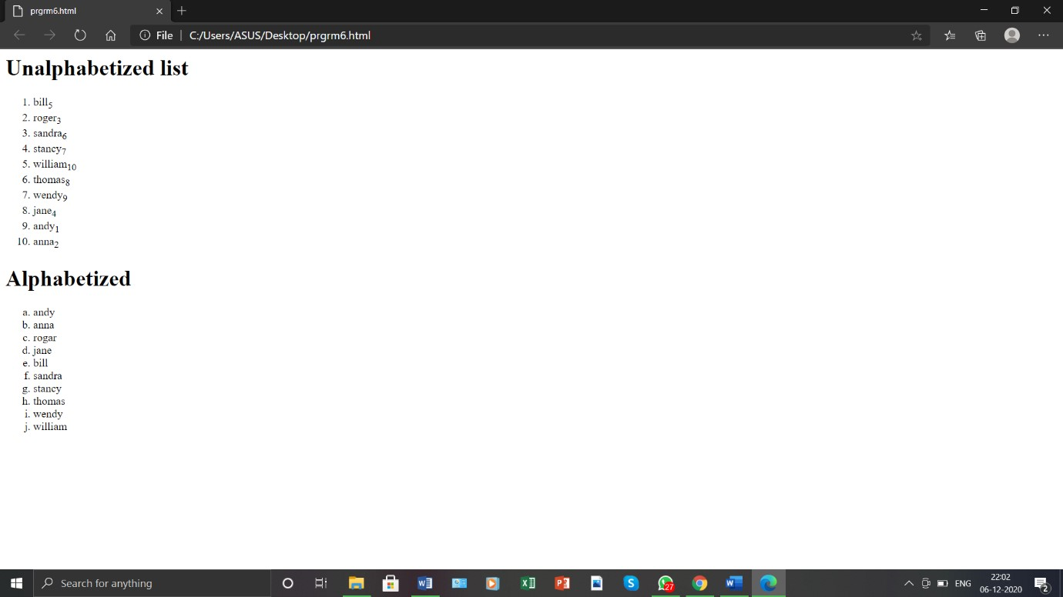

7. Print the squares of the numbers 1 - 20. Each number should be on a separate line, next to it the number 2 superscripted, an equal sign and the result

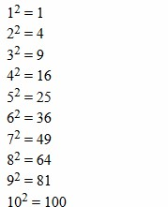

<html>

<head> </head>

<body>

1<sup>2</sup>=1

<br>2<sup>2</sup>=4

<br>3<sup>2</sup>=9

<br>4<sup>2</sup>=16

<br>5<sup>2</sup>=25

<br>6<sup>2</sup>=36

<br>7<sup>2</sup>=49

<br>8<sup>2</sup>=64

<br>9<sup>2</sup>=81

<br>10<sup>2</sup>=100

<br>11<sup>2</sup>=121

<br>12<sup>2</sup>=144

<br>13<sup>2</sup>=169

<br>14<sup>2</sup>=196

<br>15<sup>2</sup>=225

<br>16<sup>2</sup>=256

<br>17<sup>2</sup>=289

<br>18<sup>2</sup>=324

<br>19<sup>2</sup>=361

<br>20<sup>2</sup>=400

</body>

</html>

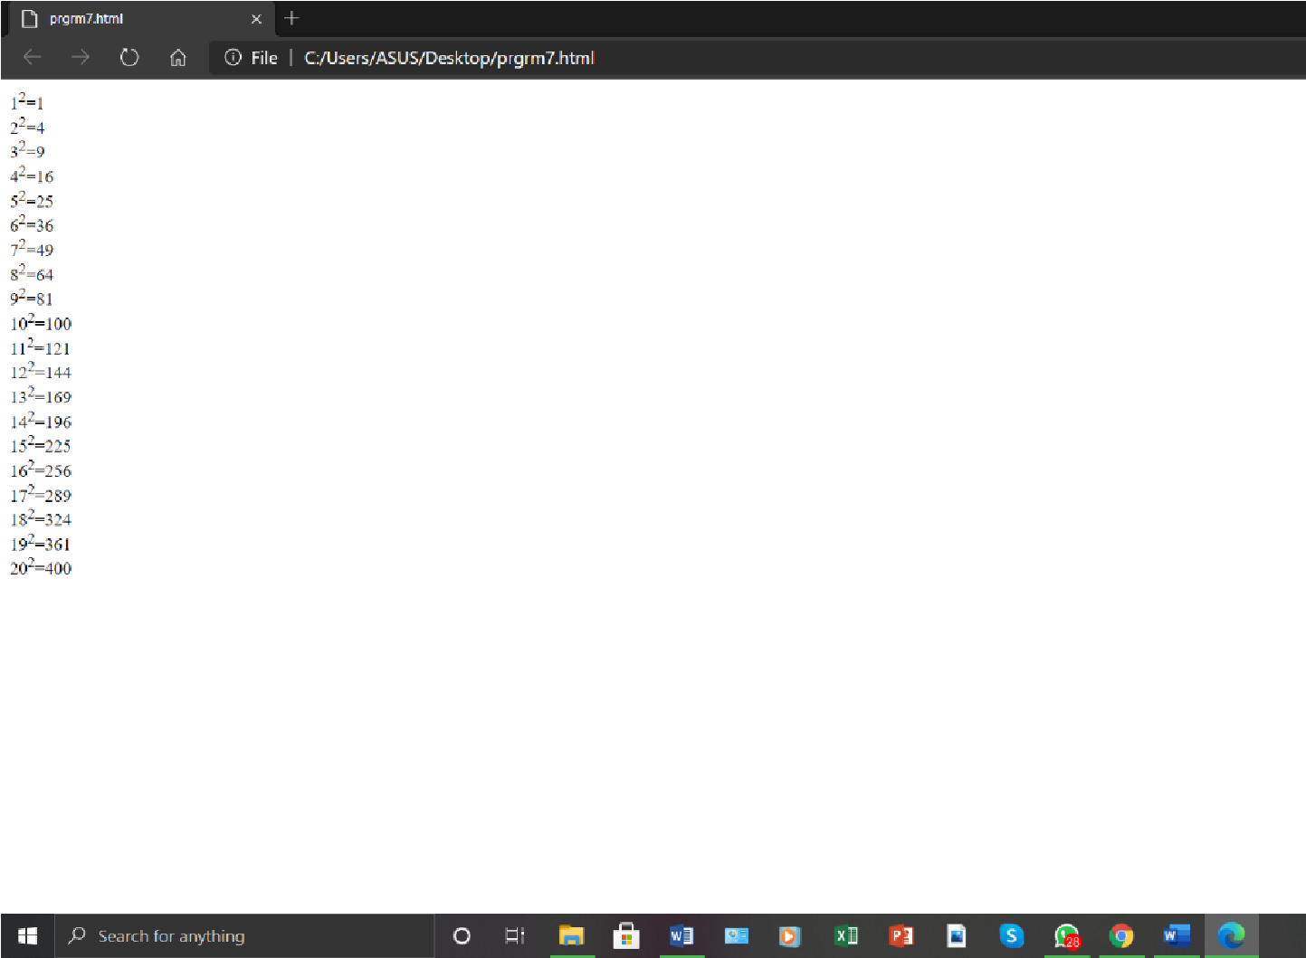

8. Print a definition list with 5 items.

<html>

<head>

</head>

<body>

<dl>

<dt>PTO</dt>

<dd>PLEASE TURN OVER</dd>

<dt>AM</dt>

<dd>ANTE MERIDIAN</dd>

<dt>PM</dt>

<dd>POST MERIDIAN</dd>

<dt>ATM</dt>

<dd>AUTOMATED TELLER MACHINE</dd>

<dt>URL</dt>

<dd>UNIFORM RESOURCE LOCATOR</dd>

</dl>

</body>

</html>

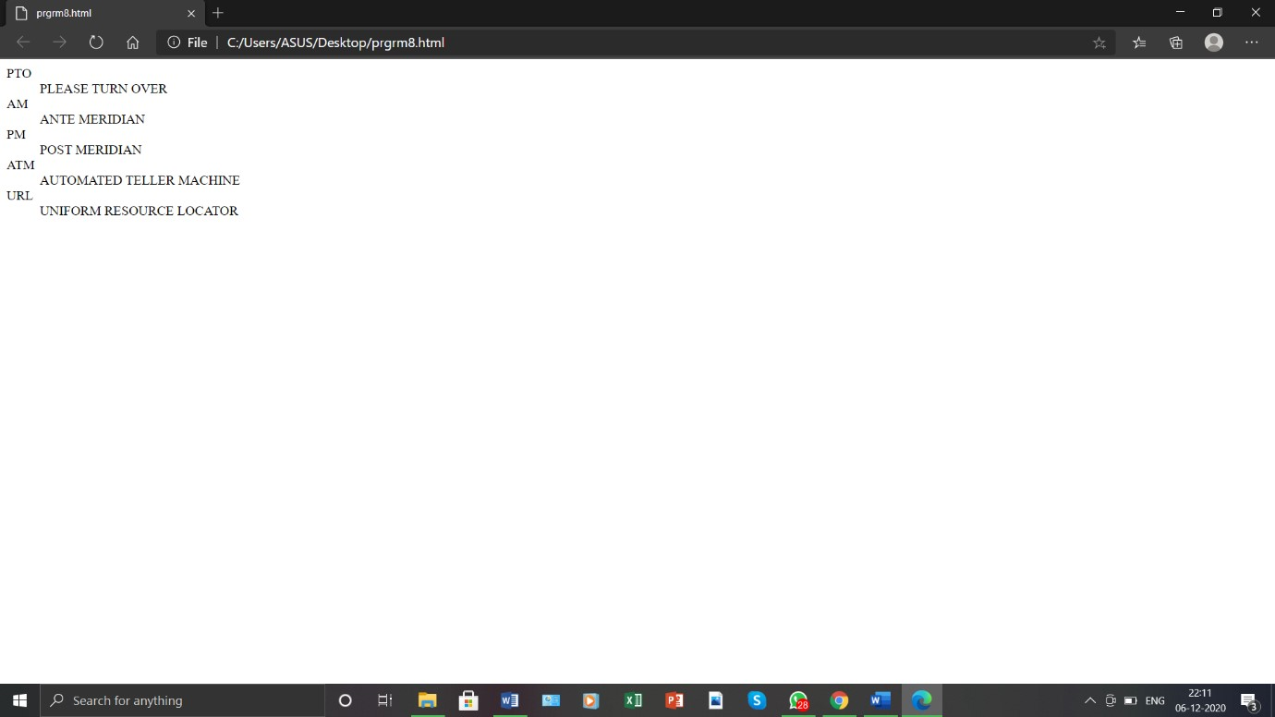

1. Display an image that has a border of size 2, a width of 200, and a height of 200.

<html>

<head>

</head>

<body>

<img src="baby.jfif" width="200" height="200" border="2"> </body>

</html>

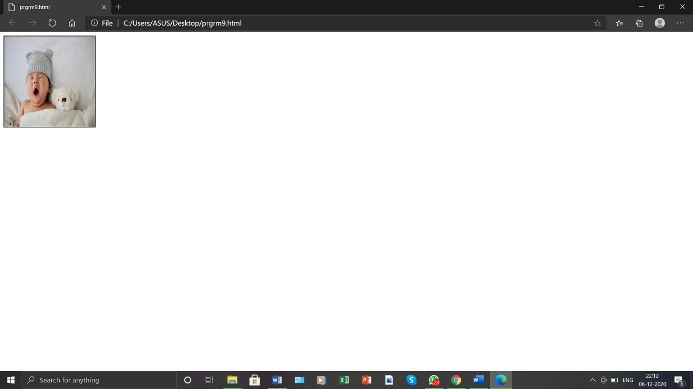

1. Print ten acronyms and abbreviations of your choosing, each separated by two lines. Specify the data that the abbreviations and acronyms represent

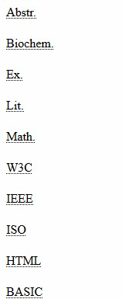

<html>

<head>

</head>

<body>

<abbr title="Abstract">Abstr</abbr>

<br>

<br><abbr title="Biochemistry">BioChem</abbr> <br>

<br><abbr title="External">Ex</abbr>

<br>

<br><abbr title="Literature">Lit</abbr>

<br>

<br><abbr title="Mathematics">Math</abbr>

<br>

<br><abbr title="World Wide Web Consortium">W3C</abbr>

<br>

<br><abbr title="Institute of Electrical and Electronics Engineers">IEEE</abbr> <br>

<br><abbr title="International Organization for Standardization">ISO</abbr> <br>

<br><abbr title="Hyper Text Markup Language">HTML</abbr>

<br>

<br><abbr title="Begginners All-purpose Symbolic Instruction Code">BASIC</abbr>

</body>

</html>

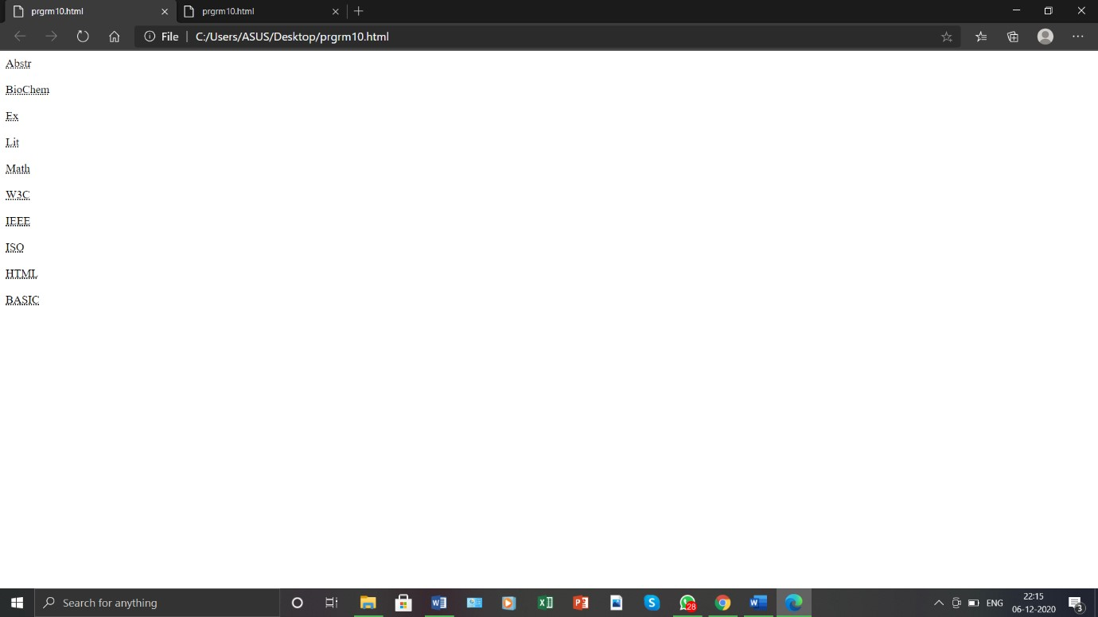

11. Print two addresses in the same format used on the front of envelopes (senders address in top left corner, receivers address in the center

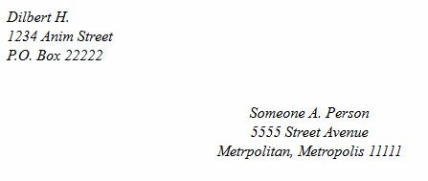

<html>

<head>

<style>

.a{position: absolute;left: 300px;top: 120px;}

</style>

</head> <body> <i>Dilbert H.

<br>1234 Anim street

<br>P.O. Box 22222</i>

<div class="a">

<i>

Someone A.person

<br>5555 Street Avenue

<br>Metroplitan,metropolis 1111

</i>

</div>

</body>

</html>

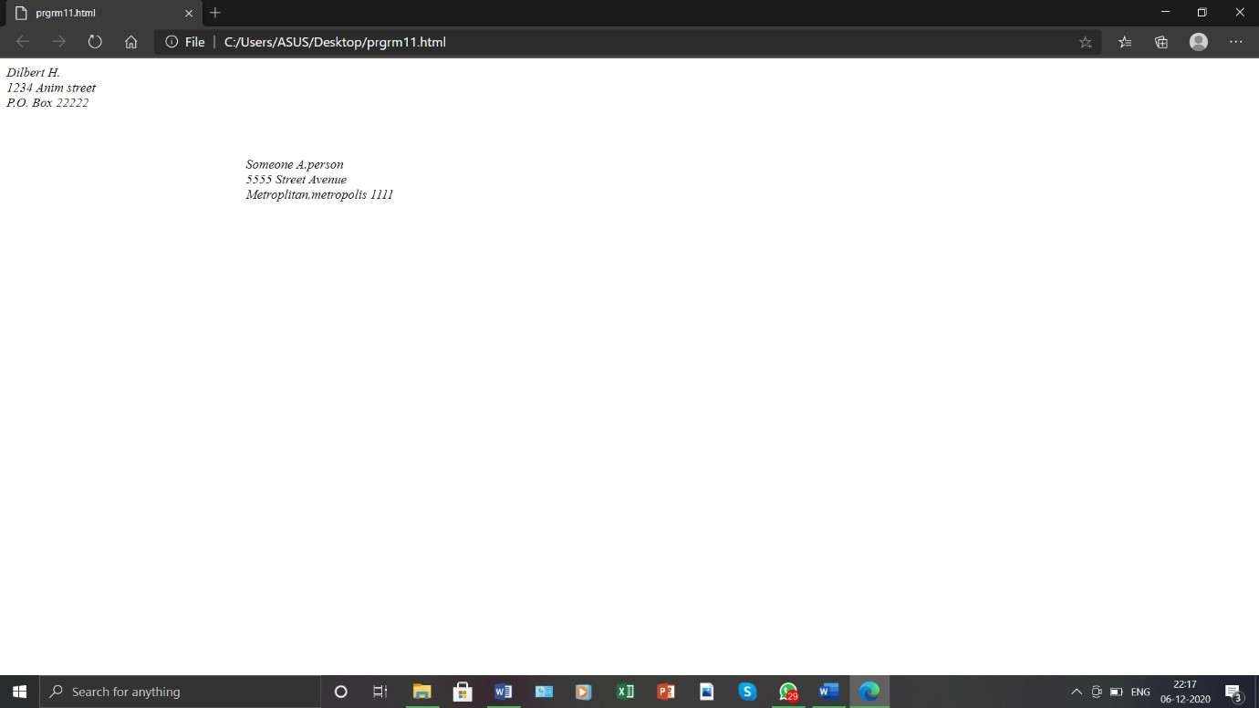

12. Create an HTML page with the following contents:

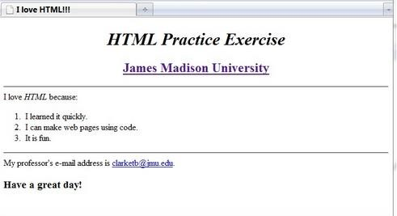

<html>

<head>

</head>

<frameset rows="30%,25%,25%">

<frame src="pr12.1.html">

<frame src="pr12.2.html">

<frame src="pr12.3.html">

</frameset>

</html> <html>

<head>

</head>

<body>

<br>

<h1><center>HTML Partice Exercise</center></h1>

<center><a href="www.jmu.edu"><h2>James Madison University</h2></center>

</body>

</html> <html>

<head>

</head>

<body>

<h3>I Love HTML because:</h3>

<ol type="1">

<li>I learned it quickly</li>

<li>I can make web pages using code</li>

<li>it is fun</li>

</ol>

</body>

</html> <html>

<head>

</head>

<body>

<h4>My professor email address is <a

href="clarketb@jmu.edu">clarketb@jmu.edu</a></h4>

<h2>Have a great day!</h2>

</body>

</html>

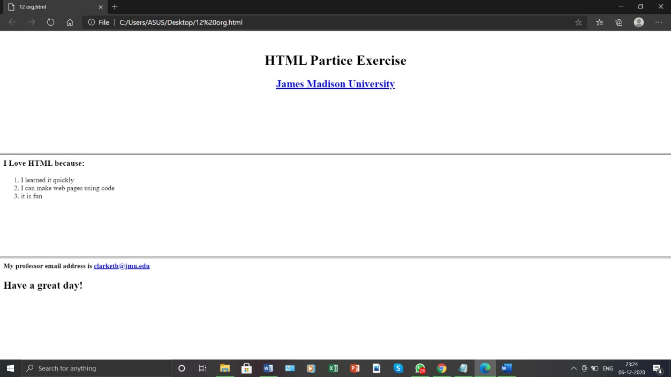

13. Create the following table

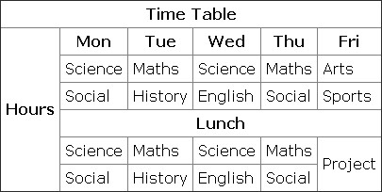

<html>

<head>

</head>

<body>

<table border="2" cellpadding="6">

<tr>

<th colspan="6">Time Table</th>

</tr>

<tr>

<td rowspan="6">Hour</td>

<td>mon</td>

<td>tue</td>

<td>wed</td>

<td>thu</td>

<td>fri</td>

</tr>

<tr>

<td>Science</td>

<td>Maths</td>

<td>Science</td>

<td>Maths</td>

<td>Arts</td>

</tr>

<tr>

<td>Soical</td>

<td>History</td>

<td>English</td>

<td>Soical</td>

<td>Sports</td>

</tr>

<tr>

<td colspan="5"><b><center>Lunch</center></b></td>

</tr>

<tr>

<td>Science</td>

<td>Maths</td>

<td>Science</td>

<td>Maths</td>

<td rowspan="2">project</td>

</tr>

<tr>

<td>Soical</td>

<td>History</td>

<td>English</td>

<td>Soical</td>

</tr>

</table>

</body>

</html>

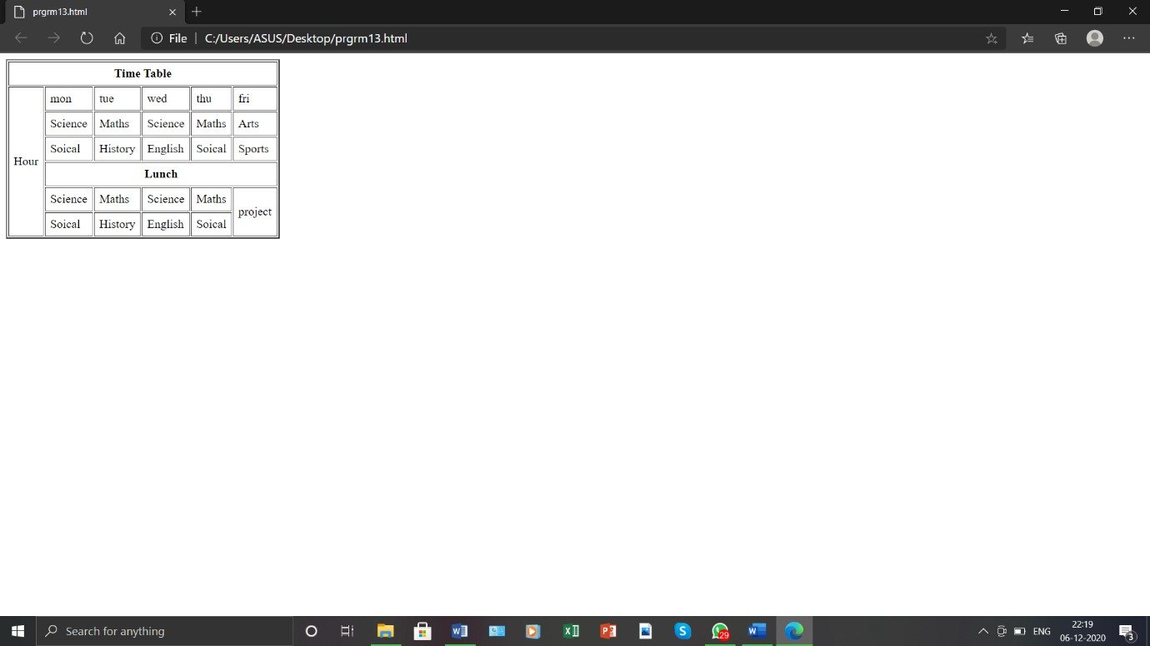

14. Create a HTML Page which looks like the one given below

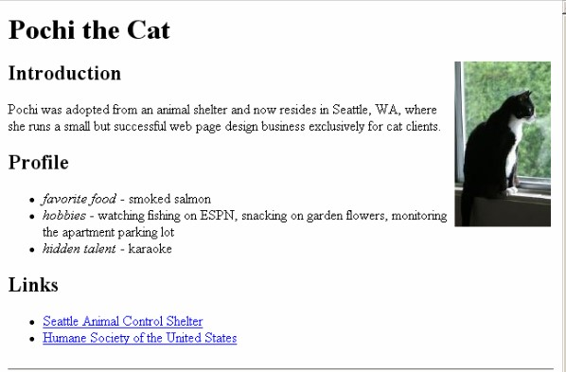

<html>

<head>

<style>

.a img{position: absolute;left: 490px;top: 60px;}

</style>

</head>

<body>

<h1><b>Pochi the Cat</b></h1>

<h3><b>Introduction</b></h3>

<br>

Pochu was adopted from an animal shelter in Seattle,WA,where she runs <br> a small but

successful web page design business exclusively for cat clients.

<h3><b>Profile</b></h3>

<li><i>favorite food</i>-smoked salmon</li>

<li><i>hobbies</i>-watching fishing on ESPN,snacking on garden

flowers,monitoring<br>the apartment parking lot</li>

<li><i>hidden talent</i>-karaoke</li>

<h3><b>Links</b></h3>

<br><li><a href="www.Seattle.com">Seattle Animal Control Shelter</a></li></br>

<li><a href="www.Humane.com">Humane Society of the United States</a></li>

<div class="a">

<img src="cat.jpg" width="200" height="200">

</div>

</body>

</html>

